COVER PAGE
Growing Resilience

Restoring Land, Rebuilding Livelihoods and Strengthening Community Resilience in Enjema District
A GEF Small Grants Programme Knowledge Magazine
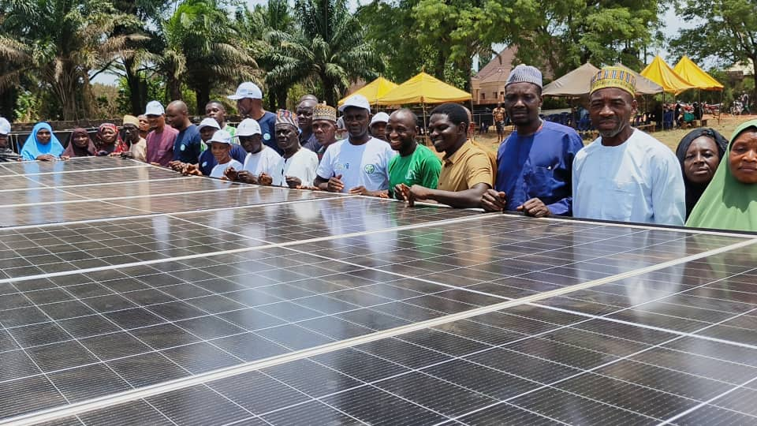

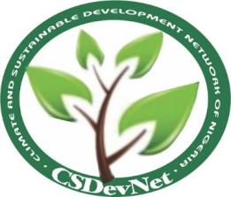

Inside Cover
Publisher
Climate and Sustainable Development Network (CSDevNet)
Supported by
Global Environment Facility Small Grants Programme (GEF-SGP)
United Nations Development Programme (UNDP)

Project title:
Addressing Land Degradation and Climate Change Through Sustainable and Climate-Smart Agriculture in Coal Mining Communities

Acknowledgements
Climate and Sustainable Development Network (CSDevNet) sincerely thanks the Global Environment Facility Small Grants Programme (GEF-SGP) and the United Nations Development Programme (UNDP) for their financial and technical support. We also appreciate the invaluable contributions of the Ankpa Local Government Area, the Onu Ankpa, the Onu Enjema, traditional institutions, government agencies, media, community leaders, women and youth groups, Village Savings and Loan Associations (VSLAs), farmer cooperatives, community volunteers, and all project beneficiaries. Their commitment, partnership, and active participation have made this project and the Community Green Action Plan (CoGAP) possible.

Disclaimer
This publication was produced by Climate and Sustainable Development Network (CSDevNet) under the United Nations Development Programme (UNDP)-GEF Small Grants Programme. The views expressed are those of the authors and do not necessarily reflect the official positions of GEF, UNDP, or their partners. The publication is intended for knowledge sharing, learning, and the promotion of community-led environmental sustainability and climate resilience.

Foreword

From Vision to Community Transformation
By the Chairman, Ankpa Local Government Area
Sustainable development is most meaningful when it improves the lives of people while protecting the natural resources upon which future generations depend. Across many rural communities in Nigeria, environmental degradation, climate change, and declining agricultural productivity continue to threaten livelihoods, food security, and local economic development. Enjema District is one such community, where years of land degradation, unsustainable resource use, and the impacts of coal mining have placed increasing pressure on both the environment and the resilience of farming households.
The implementation of the project, Addressing Land Degradation and Climate Change through Sustainable and Climate-Smart Agriculture in Coal Mining Communities, has demonstrated that these challenges can be addressed through strong partnerships, community ownership, and practical investment in sustainable livelihoods. Supported by the Global Environment Facility Small Grants Programme (GEF-SGP) and implemented by the Climate and Sustainable Development Network (CSDevNet), the project has combined environmental restoration with agricultural innovation, community mobilisation, and institutional collaboration to create a practical model for sustainable rural development.
What distinguishes this initiative is its integrated approach. Rather than addressing environmental degradation as an isolated issue, the project recognises the close relationship between healthy ecosystems, productive agriculture, economic opportunity, and effective local governance. Investments in solar-powered irrigation, climate-smart agriculture, sustainable aquaculture, Village Savings and Loan Associations (VSLAs), environmental awareness, and landscape restoration have strengthened the capacity of community members to improve their livelihoods while protecting the environment.
The development and validation of the Community Green Action Plan (CoGAP) is particularly significant. It provides Enjema District with a shared vision and practical roadmap for environmental management that extends beyond the lifespan of this project. It also reflects the collective commitment of traditional institutions, government agencies, civil society organisations, farmers, women, youth, and community leaders to work together towards a more resilient and sustainable future.
As Chairman of Ankpa Local Government Area, I commend all partners whose commitment has made these achievements possible. I particularly acknowledge the leadership of CSDevNet, the support of the GEF Small Grants Programme and UNDP, the contributions of the Onu Ankpa and traditional institutions, the Federal University of Lokoja, and the remarkable participation of the people of Enjema District.
This publication captures not only the activities undertaken during the project but also the lessons, partnerships, and community-driven innovations that have emerged throughout implementation. It demonstrates that when communities are empowered with knowledge, appropriate technologies, and inclusive institutions, they become active custodians of their environment and architects of their own development.
It is my hope that the experiences documented in this magazine will inspire similar initiatives across Ankpa Local Government Area, Kogi State, and other mining-affected communities throughout Nigeria.
Together, we have laid the foundation for a greener, healthier, and more prosperous Enjema.

Hon. Engr. Ademu Muhammed Yahaya
Chairman,
Ankpa Local Government Area

Message from the National Coordinator
United Nations Development Programme Global Environment Facility Small Grants Programme (UNDP GEF SGP), Nigeria
The United Nations Development Programme Global Environment Facility Small Grants Programme (UNDP GEF SGP) was established on the belief that lasting environmental solutions are achieved when communities are empowered to lead the process. The experience in Enjema District is a compelling demonstration of this principle in action.
This project has shown that restoring degraded landscapes, strengthening livelihoods, and improving environmental governance are not separate ambitions but mutually reinforcing to enhance the Sustainable Development Goals (SDG). Through investments in climate-smart agriculture, sustainable aquaculture, renewable energy, ecosystem restoration, and community institutions, the people of Enjema have laid the foundation for a more resilient and sustainable future.
A particularly noteworthy achievement is the development of the Community Green Action Plan (CoGAP). More than a project output, the CoGAP represents a shared vision developed through dialogue among traditional institutions, local government, women, youth, farmers, and other stakeholders. It provides a practical framework for sustaining environmental action and offers a model that can inform similar initiatives in other mining-affected communities across Nigeria.
This magazine captures not only the project's achievements but also the partnerships, innovation, and community leadership that made them possible. It demonstrates how locally driven initiatives can contribute meaningfully to national environmental priorities and global commitments on biodiversity conservation, land restoration, and climate resilience.
I commend the Climate and Sustainable Development Network (CSDevNet), Ankpa Local Government Area, traditional institutions, community members, and all partners for their dedication and collaborative spirit throughout the implementation of this project. It is my hope that the community beneficiaries will take ownership of the outcomes and that the lessons documented here will inspire greater investment in community-led environmental action and encourage the replication of this successful model across Nigeria.

Dr. (Mrs.) Ibironke Favour Olubamise
National Coordinator
United Nations Development Programme Global Environment Facility Small Grants Programme (UNDP GEF-SGP), Nigeria

Message from the National Network Coordinator, CSDevNet
This publication documents more than the completion of a project. It captures how a community responded to environmental degradation with practical, locally driven solutions.

Over the implementation period, the project demonstrated that investments in climate-smart agriculture, renewable energy, sustainable aquaculture, and community institutions can simultaneously restore degraded landscapes and strengthen rural livelihoods. The establishment of demonstration farms, Village Savings and Loan Associations, the solar-powered water system, and the Community Green Action Plan (CoGAP) provides a foundation that the community can continue to build upon long after project funding has ended.

One of the project's most significant achievements is the CoGAP itself. Developed through an inclusive process involving traditional institutions, local government, women, youth, farmers, and the private sector, it represents a shared commitment to environmental stewardship and sustainable development in Enjema.

On behalf of Climate and Sustainable Development Network (CSDevNet), I sincerely thank the Global Environment Facility Small Grants Programme (GEF-SGP), implemented by the United Nations Development Programme (UNDP), our government and traditional partners, and the people of Enjema for their trust, commitment, and collaboration. We hope the lessons and results presented in this magazine will inspire similar community-led initiatives across Kogi State and Nigeria.


Abuh Monday,
National Network Coordinator
Climate and Sustainable Development Network (CSDevNet)

ABOUT THE PROJECT

Restoring Landscapes. Strengthening Livelihoods. Building Resilient Communities.
Across many rural communities in Nigeria, climate change and environmental degradation are no longer future concerns. They are daily realities that directly influence food production, household incomes, public health, and economic opportunity. For communities located within mining landscapes, these pressures are even more pronounced. Land disturbance, declining soil fertility, unreliable rainfall, and limited livelihood opportunities continue to undermine sustainable development and increase community vulnerability.
Recognising these challenges, the Global Environment Facility Small Grants Programme (GEF-SGP), implemented by the United Nations Development Programme (UNDP), provided support to the Climate and Sustainable Development Network (CSDevNet) to implement the project "Addressing Land Degradation and Climate Change through Sustainable and Climate-Smart Agriculture in Coal Mining Communities" in Enjema District, Ankpa Local Government Area of Kogi State.
The project was conceived as an integrated response to the interconnected environmental, economic, and social challenges facing the community. Rather than focusing on a single intervention, it combined landscape restoration, climate-smart agriculture, sustainable aquaculture, community organisation, environmental governance, and financial inclusion into a unified development model.
At its core, the project sought to demonstrate that restoring degraded ecosystems and improving rural livelihoods are mutually reinforcing objectives. Healthy landscapes support productive agriculture, while stronger livelihoods reduce pressure on natural resources and encourage long-term environmental stewardship.
Implementation was built around five mutually reinforcing pillars:
- Promoting climate-smart agricultural practices that improve soil health, increase productivity, and strengthen resilience to climate variability.
- Establishing integrated aquaculture systems powered by renewable energy to diversify household incomes and improve food security.
- Strengthening community organisation through Village Savings and Loan Associations (VSLAs) and farmer cooperatives that enhance financial inclusion and collective action.
- Raising environmental awareness while promoting ecosystem restoration through economic tree planting and sustainable land management.
- Developing a Community Green Action Plan (CoGAP) to provide a long-term framework for community-led environmental governance and coordinated local action.
The project was implemented through a participatory approach that placed community ownership at the centre of decision-making. Traditional institutions, local government authorities, women and youth groups, farmer associations, technical experts, and development partners worked together to identify priorities, implement activities, and shape the future direction of environmental management in Enjema District.
Beyond delivering infrastructure and training, the project invested in strengthening local institutions capable of sustaining progress beyond the grant period. The establishment of functional VSLAs, demonstration farms, integrated aquaculture facilities, and the Community Green Action Plan provides a foundation upon which future investments and partnerships can build.
The project also demonstrates how renewable energy, sustainable agriculture, environmental restoration, and inclusive governance can be combined within a single community development framework to address multiple development challenges simultaneously. This integrated approach reflects growing international recognition that climate resilience, ecosystem restoration, food security, and local economic development are closely interconnected.
As documented throughout this magazine, the achievements of the project extend beyond physical outputs. They represent meaningful progress towards stronger environmental governance, improved livelihood opportunities, enhanced community resilience, and a shared commitment to protecting the natural resources upon which future generations depend.
Project at a Glance
- Project Value: 45,000 USD
- Duration: 12 Months
- Target beneficiaries: Women, youth, farmers, cooperatives
- Location: Enjema District, Ankpa LGA, Kogi State

Why Enjema?

A Community at the Crossroads of Environmental Degradation and Opportunity
Nestled within Ankpa Local Government Area of Kogi State, Enjema District is a predominantly agrarian community where agriculture has sustained households for generations. The fertile lands of the district have long supported the cultivation of cassava, maize, yam, vegetables, and other food crops, while its rivers and wetlands have provided opportunities for fishing and small-scale livestock production. For many families, farming is not simply an occupation but the foundation of household income, food security, and cultural identity.
Yet beneath this agricultural landscape lies one of Kogi State's most significant mineral resources, coal. For decades, coal extraction has contributed to local economic activity, creating employment opportunities and generating income for some households. However, the environmental costs associated with mining have increasingly threatened the very natural resources upon which the wider community depends.
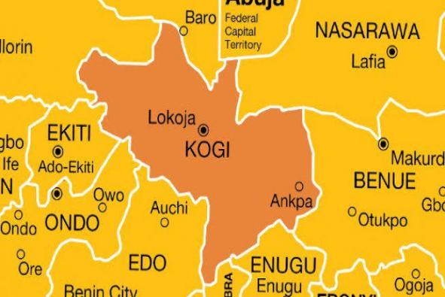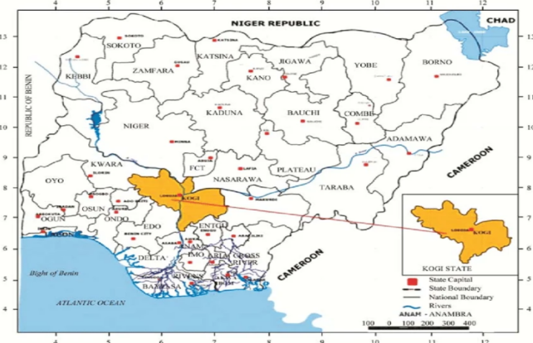
As mining activities expanded over the years, large areas of land were disturbed without adequate reclamation. Productive farmland gradually gave way to exposed soils, abandoned mine sites, and degraded landscapes. Vegetation cover declined, erosion intensified, and fertile topsoil was lost. These environmental changes have steadily reduced agricultural productivity while increasing the vulnerability of farming households to climate variability.
The environmental pressures facing Enjema extend beyond mining alone. Climate change has emerged as a significant threat to agricultural production across the district. Farmers report increasingly unpredictable rainfall patterns, shorter growing seasons, prolonged dry spells during critical planting periods, and more frequent episodes of intense rainfall that damage crops and accelerate soil erosion. These changing climatic conditions have disrupted traditional farming calendars and increased production risks for smallholder farmers who rely almost entirely on rain-fed agriculture.
The project's baseline assessment confirmed that agriculture remains the primary source of livelihood for most households within the community. However, the survey also revealed significant constraints to productivity, including declining soil fertility, limited access to improved agricultural technologies, inadequate irrigation infrastructure, poor access to extension services, and increasing environmental degradation associated with mining activities. Community members consistently identified access to water, improved farm inputs, technical knowledge, and affordable finance as essential requirements for improving agricultural productivity and strengthening household resilience.
Environmental degradation has also created broader socio-economic consequences. As agricultural productivity declines, household incomes become increasingly unstable, particularly among women and youth who depend heavily on farming and related economic activities. Limited livelihood diversification increases dependence on environmentally fragile natural resources, creating a cycle in which environmental degradation and rural poverty reinforce one another. Without strategic intervention, these trends threaten long-term food security, economic stability, and community well-being.
Despite these challenges, Enjema possesses significant assets that make it well positioned for sustainable transformation. The district has fertile agricultural land, strong traditional institutions, active community leadership, and a population with extensive farming knowledge and experience. During project implementation, these strengths became evident through the donation of community land for the demonstration farm, active participation in Village Savings and Loan Associations (VSLAs), volunteer support during project activities, and broad stakeholder commitment to environmental restoration and sustainable agriculture.
These characteristics made Enjema an ideal location for demonstrating an integrated approach to climate resilience. Rather than treating environmental restoration, agriculture, livelihoods, and governance as separate issues, the project recognised that lasting change requires coordinated action across all these areas. Investments in renewable energy, climate-smart agriculture, aquaculture, financial inclusion, environmental awareness, and participatory environmental planning were therefore designed to reinforce one another while strengthening the community's capacity to manage future environmental and economic challenges.
Today, Enjema is increasingly recognised not only as a community confronting the legacy of environmental degradation but also as an emerging example of how local leadership, strategic partnerships, and community participation can transform environmental challenges into opportunities for sustainable development. The lessons emerging from Enjema demonstrate that restoring degraded landscapes is not solely about rehabilitating ecosystems. It is equally about restoring livelihoods, strengthening institutions, creating new economic opportunities, and building resilient communities capable of adapting to an increasingly uncertain climate.

Enjema at a Glance (Sidebar)
Location
- Enjema District, Ankpa Local Government Area, Kogi State, Nigeria
Primary Livelihoods
- Crop farming
- Small-scale livestock production
- Fishing
- Trading
- Artisanal mining
Major Environmental Challenges
- Land degradation from coal mining
- Soil fertility decline
- Climate variability
- Soil erosion
- Limited dry-season water availability
- Environmental pollution
Community Strengths
- Strong traditional leadership
- Active farmer groups
- High community participation
- Agricultural experience
- Community-donated land for project implementation

Environmental Facts (Infographic Panel)
- 1000+ community members trained in climate-smart agriculture and sustainable aquaculture.
- 20 Village Savings and Loan Associations established to strengthen financial inclusion and collective action.
- 1 solar-powered borehole providing reliable water for integrated agriculture and aquaculture.
- 20 tarpaulin ponds stocked with 10,000 juvenile catfish.
- 1000 Tenera oil palm seedlings planted across 8 hectares of community land.
- 1 Community Green Action Plan (CoGAP) developed and validated to guide long-term environmental governance.

PROJECT JOURNEY

From Planning to Lasting Impact
Transforming environmental challenges into sustainable opportunities required more than individual activities. It demanded careful planning, strong community partnerships, and a sequence of coordinated interventions that built on one another. Beginning with community engagement and stakeholder consultations, the project progressed through infrastructure development, capacity building, environmental governance, and ecosystem restoration. Each milestone strengthened local ownership while laying the foundation for the next stage of implementation.
The journey reflects a practical model of integrated rural development where community participation, renewable energy, climate-smart agriculture, sustainable aquaculture, and environmental governance work together to deliver lasting environmental and socio-economic benefits.

Timeline of Key Milestones
October 2025
Community Entry & Stakeholder Engagement
Courtesy visits to the Onu Ankpa and community leaders secured local endorsement, strengthened trust, and resulted in the donation of land for project implementation.

October 2025
Project Inception Workshop
More than 180 stakeholders were introduced to the project objectives, implementation approach, and expected outcomes.
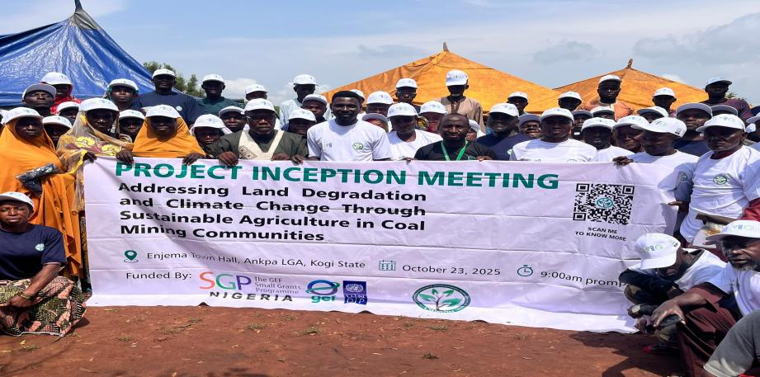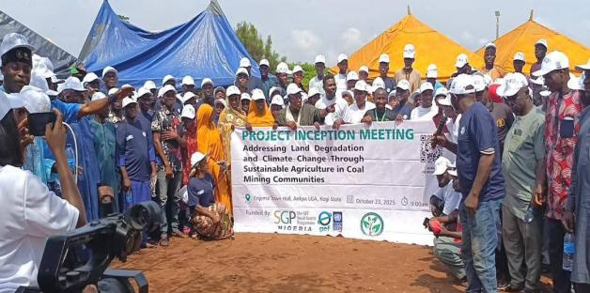

October 2025
Baseline Survey
Household and community assessments established baseline data on livelihoods, agriculture, environmental challenges, and community priorities.
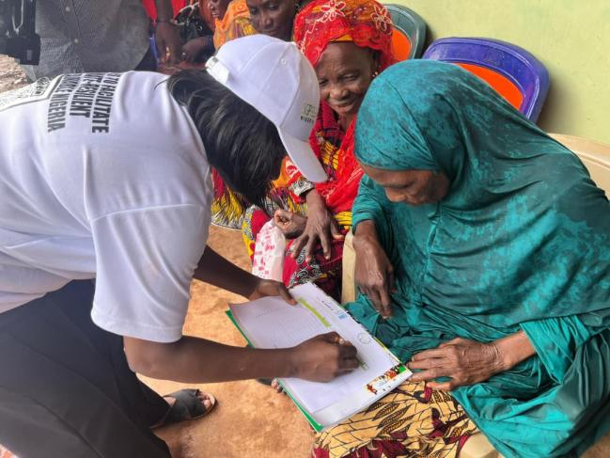
November 2025 - February 2026
Solar Borehole Installation
Solar-powered borehole, storage tanks, and eight solar panels installed to provide reliable water for agriculture and aquaculture.

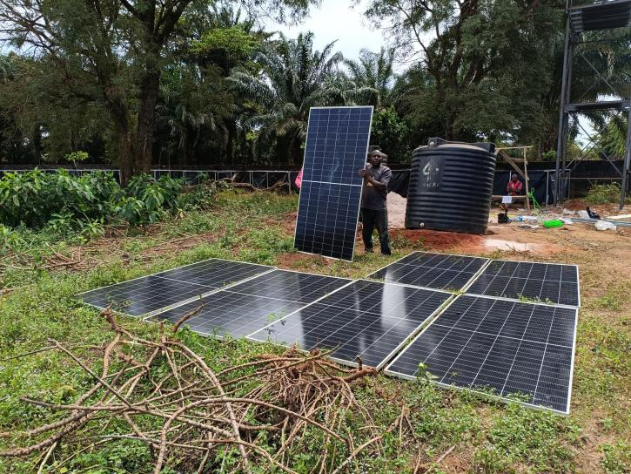

February 2026
Demonstration Farm Established
Climate-smart agriculture demonstration plots established with improved cassava, maize, vegetables, and integrated irrigation systems.
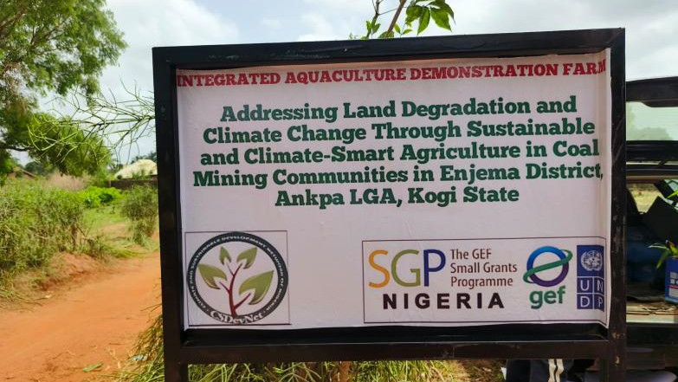

March 2026
Village Savings & Loan Associations (VSLAs)
Twenty VSLAs established to strengthen financial inclusion, cooperative action, and sustainable livelihood development.

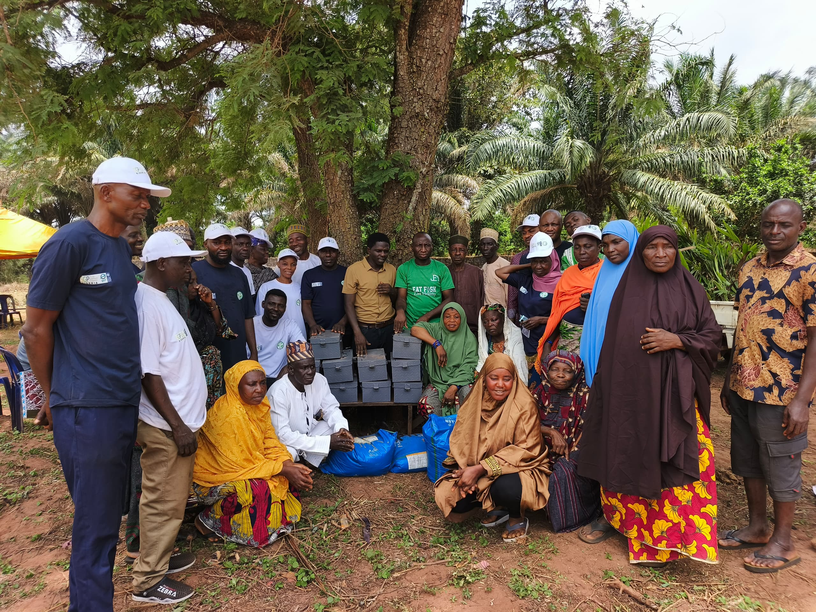

March 2026
Aquaculture Training & Fish Pond Stocking
Twenty tarpaulin ponds stocked with 10,000 juvenile catfish and managed by trained VSLA groups.
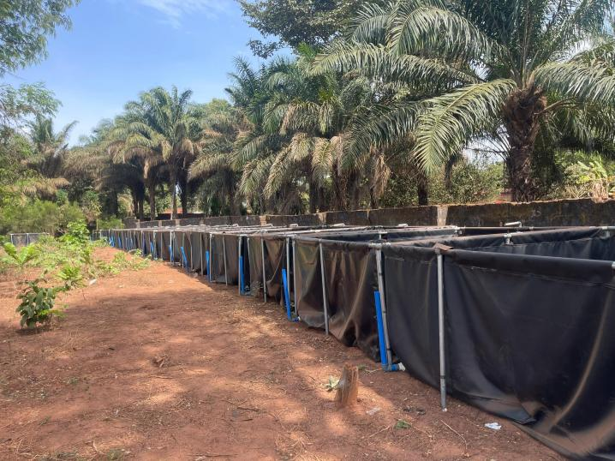

March-April 2026
Policy Advocacy & Stakeholder Engagement
Strategic advocacy meetings held with the Onu Ankpa and Ankpa LGA Chairman to strengthen environmental governance and support a just transition from coal dependence.
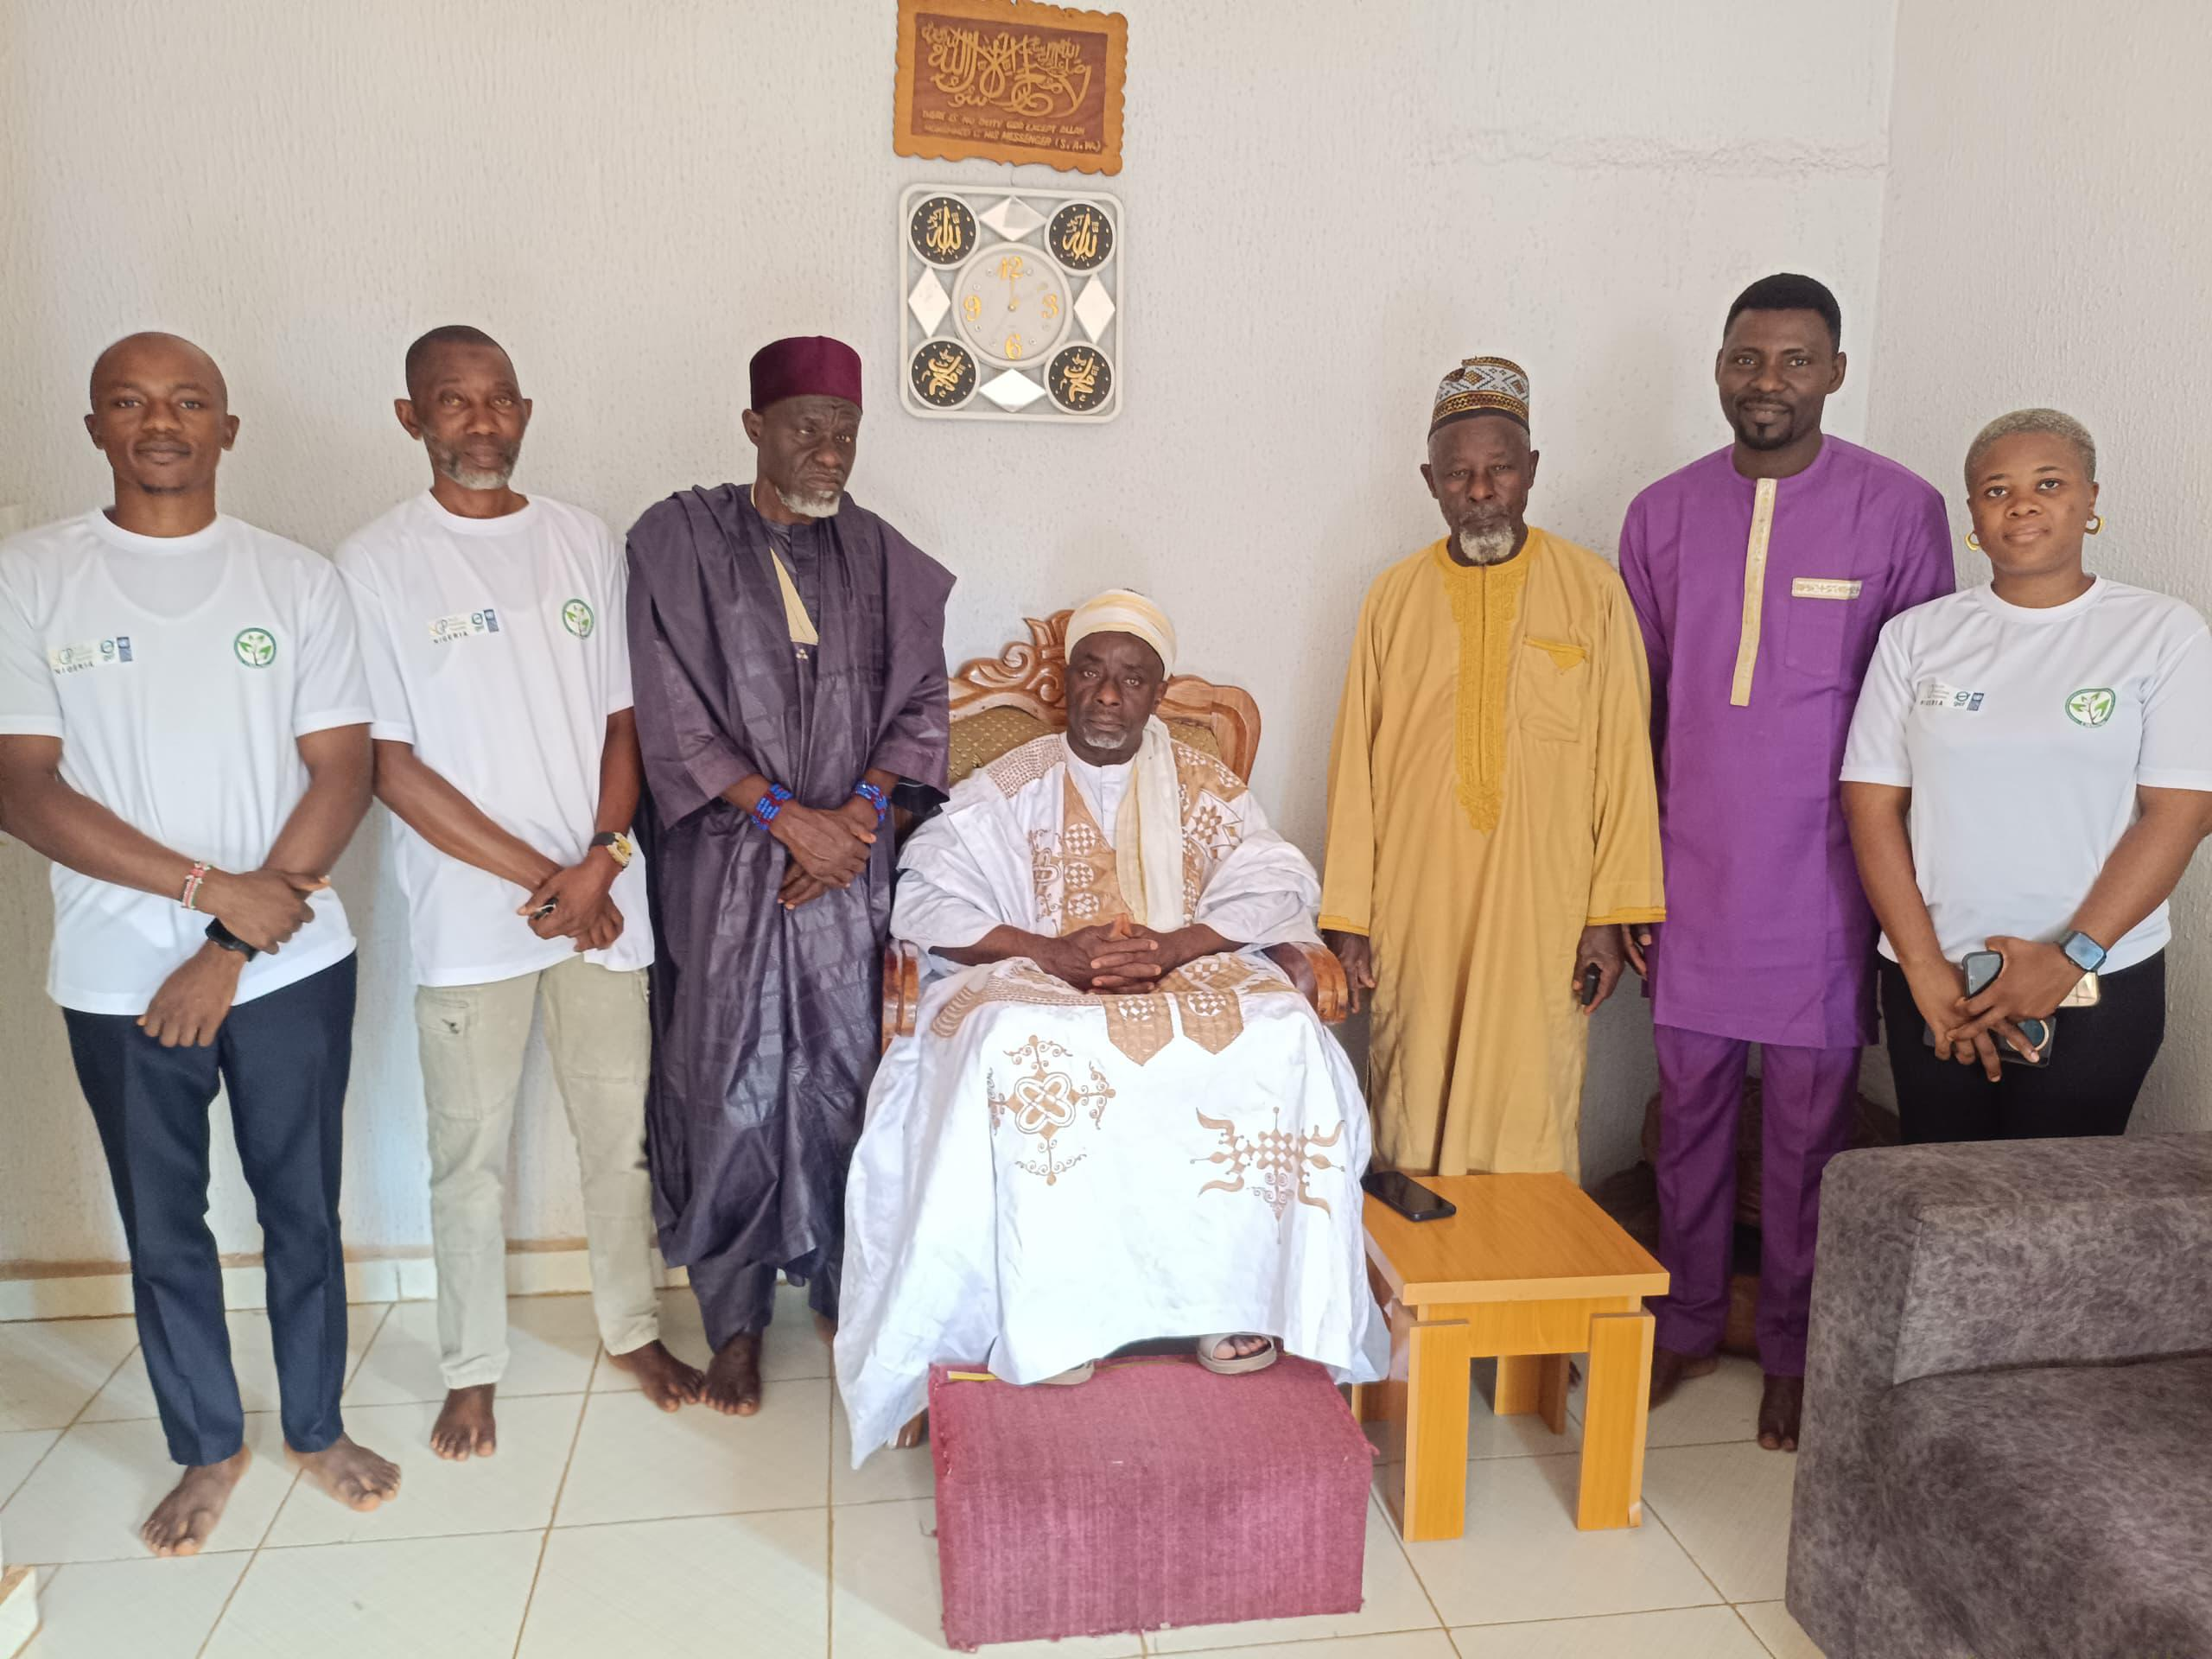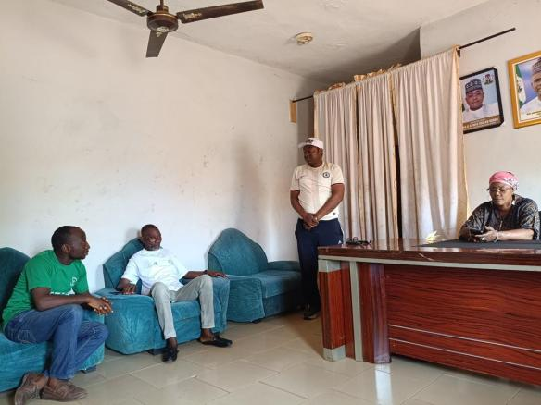

April 2026
Community Green Action Plan (CoGAP) Developed
Community consultations informed the drafting of a long-term environmental action framework for Enjema District.

April 2026
CoGAP Validation Meeting
Government officials, traditional leaders, women, youth, farmers, and business representatives validated and adopted the Community Green Action Plan.
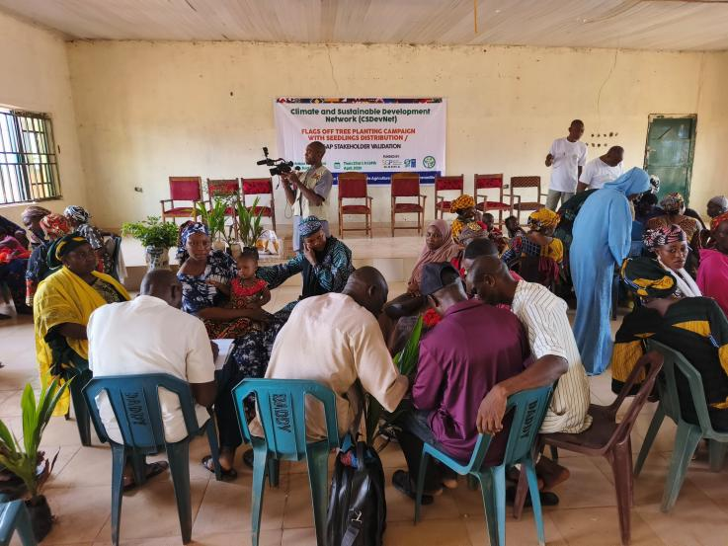

April 2026
Environmental Awareness Campaign
Community sensitisation on climate change, land degradation, coal mining impacts, and sustainable environmental management reached farmers, women, and youth groups.
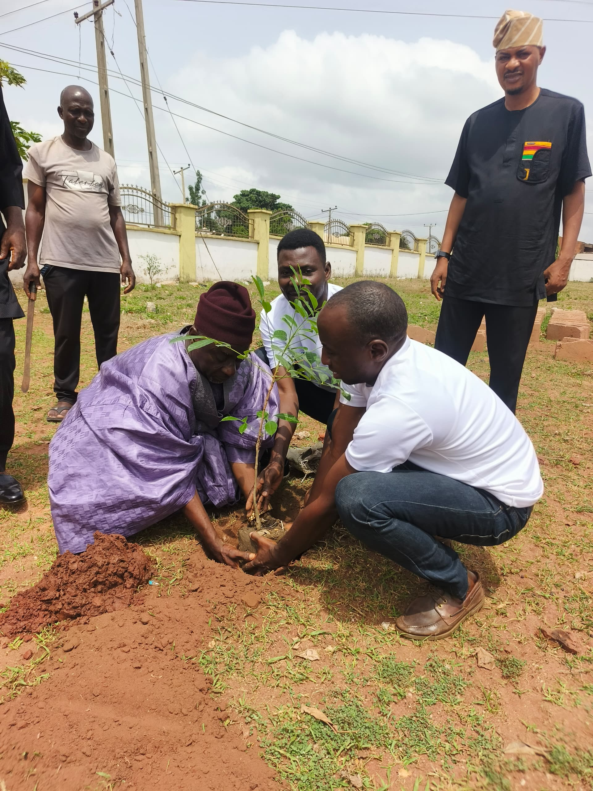

April 2026
Tree Planting Campaign
One thousand Tenera oil palm seedlings distributed and planted across eight hectares, launching a long-term community-led landscape restoration programme.

TRANSFORMING AGRICULTURE

Building Climate-Smart Farming for Food Security and Environmental Restoration
"Healthy soils, efficient water use, and diversified farming systems are the foundation of resilient communities."

Growing More While Restoring the Land
For decades, agriculture has been the backbone of livelihoods in Enjema District. Yet years of land degradation, declining soil fertility, erratic rainfall, and the environmental impacts of coal mining have steadily reduced farm productivity and increased household vulnerability. Many farmers depended on traditional practices that were becoming less effective under changing climatic conditions, resulting in declining yields and increasing production risks.
Recognising that environmental restoration and food security are inseparable, the GEF Small Grants Programme project introduced an integrated climate-smart agriculture model that demonstrates how farmers can increase productivity while conserving natural resources. Rather than promoting isolated technologies, the project established a practical learning platform where improved crop production, sustainable aquaculture, renewable energy, efficient water management, and ecosystem restoration reinforce one another.
At the centre of this approach is the five-hectare Climate-Smart Agriculture and Aquaculture Demonstration Farm donated by the Onu Enjema. The demonstration farm serves as a living classroom where farmers observe, practice, and adapt sustainable agricultural technologies before replicating them on their own farms.
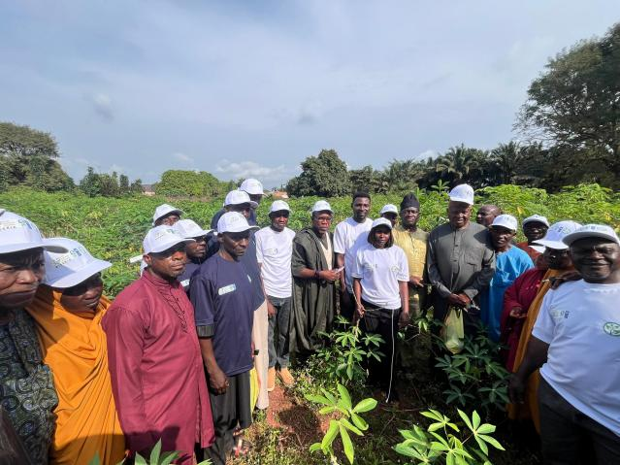

Climate-Smart Agriculture in Practice
The demonstration farm showcases practical technologies designed to increase productivity while reducing pressure on natural resources.
Improved cassava stems were planted on one hectare of land to demonstrate high-yielding, climate-resilient varieties capable of performing under changing climatic conditions. Farmers receive practical guidance on proper spacing, weed management, soil fertility improvement, and disease control.
Alongside the cassava demonstration, one hectare of improved maize was established using improved seed varieties with higher yield potential and better adaptation to local conditions. Farmers are introduced to improved planting techniques, integrated soil fertility management, and climate-smart agronomic practices that improve productivity while reducing production risks.
Vegetable production forms another important component of the integrated farming system. Tomatoes and pepper are cultivated using nutrient-rich irrigation water recycled from the aquaculture ponds. This innovative approach reduces dependence on chemical fertilizers while improving water-use efficiency and increasing vegetable production during the dry season.
The demonstration farm also introduces farmers to sustainable land management practices including composting, mulching, minimum soil disturbance, crop diversification, and integrated nutrient management. These practices improve soil structure, increase organic matter, reduce erosion, conserve moisture, and strengthen resilience against climate variability.
Together, these interventions provide practical evidence that climate-smart agriculture can simultaneously improve food production, restore degraded land, and strengthen household livelihoods.
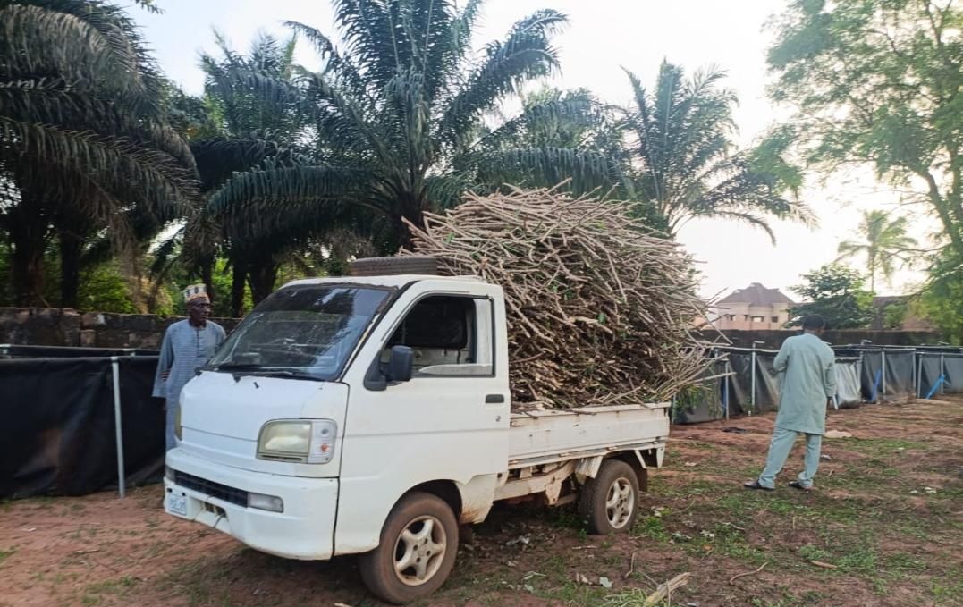

Closing the Loop: The Circular Farming Model
One of the project's most innovative achievements is the establishment of an integrated circular farming system.
Rather than treating aquaculture and crop production as separate enterprises, the demonstration farm links both systems to maximise efficiency and minimise waste.
Water enriched with natural nutrients from the fish ponds is channelled directly to vegetable plots, where it provides irrigation while supplying essential nutrients for plant growth. This approach significantly reduces fertilizer requirements, conserves freshwater resources, and transforms what would otherwise be waste into a productive agricultural input.
The result is a farming system that produces fish, vegetables, maize, and cassava while using less water, reducing production costs, and minimising environmental impacts.
This integrated approach demonstrates how smallholder farmers can improve productivity without increasing pressure on already degraded ecosystems.

Pull Quote
"The demonstration farm has shown that restoring the environment and increasing agricultural productivity can go hand in hand. Farmers are seeing practical solutions they can adopt on their own farms." - Mr, Daikwo Ogala, project technical partner

Building Community Prosperity

Stronger Groups. Stronger Livelihoods.
"When people organize, they create opportunities that no individual can achieve alone."
For many households in Enjema, limited access to finance has constrained investment in farming and alternative livelihoods. To address this challenge, the project established 20 Village Savings and Loan Associations (VSLAs) with more than 180 trained members, creating a foundation for financial inclusion, enterprise development, and collective action.
The groups were organized around key value chains: 10 aquaculture VSLAs, 5 maize and economic tree VSLAs, and 5 cassava and economic tree VSLAs. This approach links savings with productive investments while strengthening local value chains.
Women and young people have emerged as key drivers of the initiative, taking on leadership roles, managing group activities, and participating in training on financial management, governance, and climate-smart livelihoods. The VSLAs are also serving as the foundation for the formation of farmer cooperatives that will improve access to agricultural inputs, extension services, markets, and future financing opportunities.
More than savings groups, the VSLAs are strengthening social cohesion, encouraging shared responsibility, and building community resilience for long-term development.
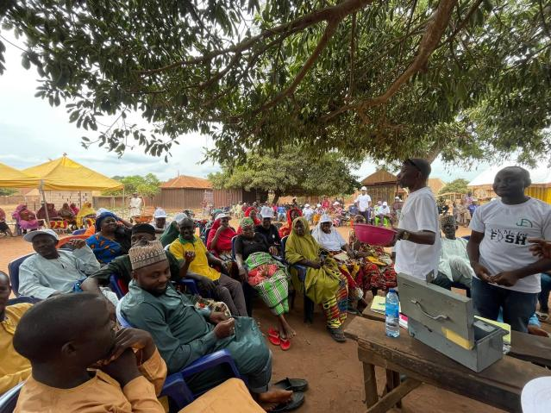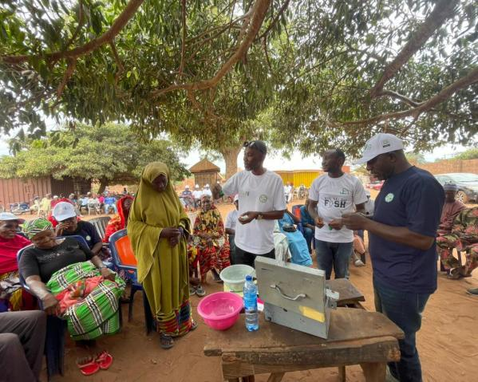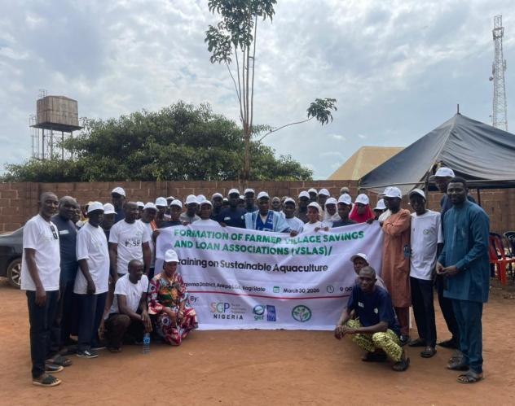

Beneficiary Voices
"Our VSLA has given us confidence to save together, invest together, and plan for the future."
Hajara Isah - VSLA Member, Enjema District
"The training has shown us that farming can become a profitable business when we work together."
Tenimu Isah - Youth Participant

WATER CHANGES EVERYTHING

Solar Energy Driving Climate-Smart Agriculture and Aquaculture
"Reliable water is transforming agriculture from a seasonal activity into a year-round livelihood opportunity."

A New Source of Opportunity
Water scarcity has long limited agricultural production in Enjema District. Farmers depended almost entirely on seasonal rainfall, making crop production increasingly unpredictable as rainfall patterns became more erratic. During the dry season, agricultural activities slowed considerably, while opportunities for irrigation and aquaculture remained largely unavailable.
To address this challenge, the project invested in renewable energy-powered water infrastructure that now serves as the backbone of the integrated demonstration farm.
A solar-powered borehole equipped with eight photovoltaic panels provides a reliable source of clean water throughout the year. Water is pumped into elevated storage tanks before being distributed across the demonstration farm to support both aquaculture and crop production.
Beyond providing water, the system demonstrates how renewable energy technologies can improve agricultural productivity while reducing dependence on fossil fuels and lowering operating costs.

Powering an Integrated Farming System
The solar-powered water system supports every component of the demonstration farm.
Reliable water supply enables continuous fish production within twenty tarpaulin ponds stocked with 10,000 juvenile catfish under the management of Village Savings and Loan Associations.
The same water also irrigates maize, cassava, vegetables, and economic tree seedlings, allowing farmers to maintain crop production beyond the traditional rainy season.
Because the system operates entirely on solar energy, operating costs remain low while greenhouse gas emissions associated with diesel-powered pumping are eliminated.
The integration of renewable energy, water management, aquaculture, and climate-smart agriculture provides a practical model that can be replicated across other rural communities facing similar environmental challenges.
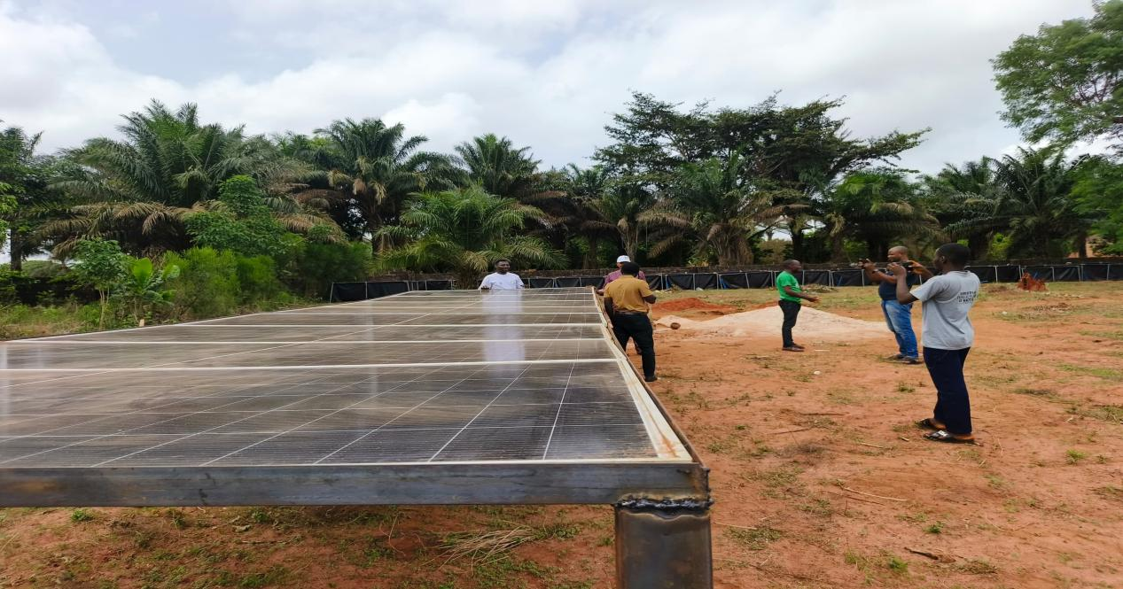

Community Benefits
The installation of the solar-powered borehole has produced benefits extending well beyond the demonstration farm.
Reliable water availability has increased confidence among farmers to invest in year-round agricultural production.
Training participants now learn practical irrigation techniques using a functioning system rather than theoretical demonstrations.
Village Savings and Loan Associations manage productive aquaculture enterprises that generate practical skills while creating future income opportunities.
The integrated system also demonstrates how renewable energy technologies can strengthen climate resilience by reducing dependence on increasingly unpredictable rainfall.
Together, these investments have transformed water from a limiting factor into a driver of sustainable agricultural development.

Project Infrastructure at a Glance
Infrastructure | Achievement
Solar Panels | 8 installed
Solar Borehole | Fully operational
Elevated Water Storage | Installed
Fish Ponds | 20 tarpaulin ponds
Fish Stock | 10,000 juvenile catfish
Irrigation | Supports crops and vegetables
Energy Source | 100% solar powered

Pull Quote
"Reliable water has changed what is possible in Enjema. Farmers can now see how renewable energy, aquaculture, and climate-smart agriculture work together to build resilient livelihoods." - HRH Yunusa Ameh, Traditional Ruler

RESTORING THE LANDSCAPE

Community Action for Environmental Recovery and Climate Resilience
"Environmental restoration is not achieved through projects alone. It is sustained when communities take ownership of their natural resources and work together to protect them for future generations."

From Awareness to Action
For many years, environmental degradation has steadily altered the landscape of Enjema District. Extensive coal mining, unsustainable land use, bush burning, deforestation, and changing rainfall patterns have contributed to declining soil fertility, reduced agricultural productivity, increased erosion, and the loss of valuable vegetation. While these challenges accumulated over decades, community consultations conducted under the GEF Small Grants Programme revealed a growing willingness among residents to reverse the trend through collective action.
Recognising that sustainable restoration requires both behavioural change and practical interventions, the project combined environmental education with visible, community-led restoration activities. Rather than treating awareness campaigns as standalone events, they were integrated with demonstration activities that enabled participants to immediately translate knowledge into action.
The Environmental Awareness Campaign brought together farmers, women groups, youth organisations, traditional leaders, community volunteers, and local government representatives to discuss the environmental impacts of coal mining, climate change, unsustainable agricultural practices, and the importance of restoring degraded landscapes. Through interactive discussions and practical demonstrations, participants explored how healthy ecosystems underpin food security, livelihoods, public health, and long-term economic development.

Tree Planting as an Investment in the Future
One of the defining moments of the project was the official flag-off of the Community Tree Planting Campaign following the validation of the Community Green Action Plan (CoGAP).
The campaign marked the transition from environmental planning to visible action.
A total of 1000 Tenera Oil Palm seedlings were planted across eight hectares of community-donated land, creating the foundation for a long-term agroforestry system that combines environmental restoration with sustainable livelihood opportunities.
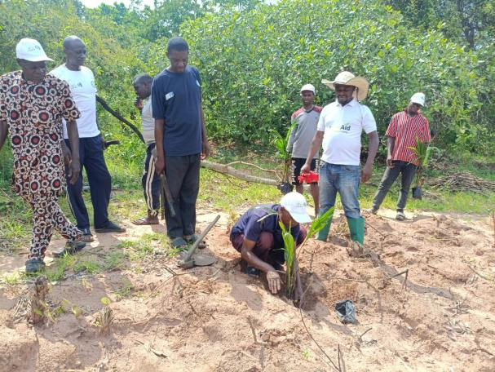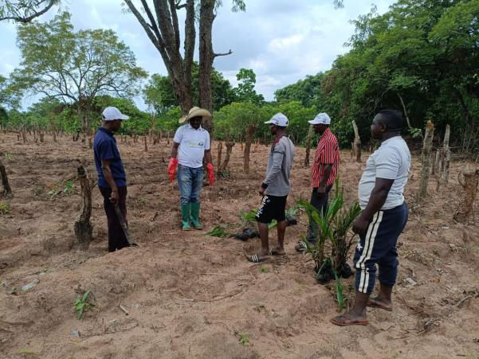
The choice of Tenera Oil Palm reflects both ecological and economic considerations. The trees contribute to improved vegetation cover, increased carbon sequestration, enhanced soil stability, and reduced surface erosion while creating a future source of household income through palm fruit production.
Unlike conventional tree planting campaigns that conclude with seedling distribution, the project established community responsibility for long-term maintenance. Farmer groups, Village Savings and Loan Associations (VSLAs), traditional institutions, and community leaders committed to protecting the plantations through routine monitoring, replacement of dead seedlings where necessary, and collective maintenance activities.
This approach strengthens ownership while improving the likelihood of long-term survival and environmental impact.

Communities Leading Environmental Restoration
Perhaps the project's greatest achievement has been the emergence of environmental stewardship as a shared community responsibility.
Women groups became active champions of sustainable land management through participation in awareness campaigns, seedling distribution, and demonstration activities.
Youth organisations supported mobilisation efforts, community sensitisation, and tree planting exercises while gaining practical knowledge of environmental conservation.
Traditional institutions provided leadership by encouraging community participation and reinforcing the importance of protecting communal natural resources.
The collaboration between community members, CSDevNet, Ankpa Local Government, and the Onu Ankpa has demonstrated that environmental restoration is most effective when local ownership is combined with institutional support.

Restoring More Than the Landscape
The project has restored more than degraded land.
It has strengthened dialogue between communities and government, improved environmental awareness, promoted collective action, and created practical examples of climate resilience that can be replicated across other coal mining communities.
The Community Green Action Plan now provides a long-term roadmap for sustaining these efforts beyond the lifespan of the current project, ensuring that restoration becomes an ongoing community development priority rather than a one-time intervention.
Through continued partnership, environmental stewardship, and shared responsibility, Enjema District is steadily transforming from a landscape shaped by degradation into one defined by resilience, sustainability, and opportunity.

Pull Quote
"Restoring degraded land is about restoring opportunity. Every tree planted today represents healthier soils, stronger livelihoods, and a more resilient future for the people of Enjema." - Abuh Monday, National Network Coordinator, CSDevNet

COMMUNITY GREEN ACTION PLAN (COGAP)

A Community Vision for a Greener Future
The Community Green Action Plan (CoGAP) is Enjema District's long-term environmental roadmap. Developed through extensive community consultations under the GEF Small Grants Programme, it provides a shared framework for restoring degraded land, promoting climate-smart agriculture, strengthening environmental governance, and improving livelihoods.
The CoGAP was validated by community leaders, women, youth, farmers, business representatives, traditional institutions, and government officials, ensuring broad ownership and commitment. It will guide coordinated action beyond the lifespan of the current project and support integration of environmental priorities into local development planning.
More than a project document, the CoGAP represents a lasting partnership between the community, Ankpa Local Government Area, traditional institutions, and CSDevNet to build a more resilient and sustainable Enjema.

RESULTS & IMPACT

Two Years of Community-Led Climate Action

At a Glance

Restoring the Environment

1,000
Tenera Oil Palm Seedlings Planted
8 Hectares
of degraded community land restored through agroforestry.

1
Solar-Powered Borehole
Providing reliable water for irrigation and aquaculture throughout the year.

8
Solar Panels Installed
Powering a clean, renewable water supply system for the demonstration farm.

Climate-Smart Agriculture

1 Hectare
Improved maize demonstration established.

1 Hectare
Improved cassava demonstration established.

Integrated Farming
Aquaculture wastewater reused to irrigate vegetables, reducing water use and improving productivity.

Building Sustainable Livelihoods

20
Aquaculture ponds installed and stocked.

10,000
Juvenue catfish introduced.
Creating a community-managed aquaculture enterprise under the VSLA model.

Strengthening Communities

20
Village Savings & Loan Associations (VSLAs)

200+
Community members trained and organized.
Building savings, leadership, entrepreneurship, and financial resilience.

Better Environmental Governance

1
Community Green Action Plan (CoGAP)
Developed, validated, and adopted through a multi-stakeholder process involving government, traditional institutions, women, youth, farmers, and local businesses.

Policy & Partnership

High-Level Advocacy Conducted With
👑 Onu Ankpa
🏢 Ankpa Local Government Area
Strengthening collaboration for environmental governance and a just transition from coal dependency.

Community Awareness
Environmental awareness campaigns reached farmers, women groups, youth, and community leaders with practical knowledge on:
🌍Land Restoration
🌍 Climate Change
🌱 Sustainable Agriculture
🌳 Tree Planting

By the Numbers
Indicator | Achievement
Community members reached | 180+
VSLAs established | 20
Fish ponds established | 20
Juvenile catfish stocked | 10,000
Solar panels installed | 8
Solar boreholes | 1
Oil palm seedlings planted | 1000
Land restored | 8 hectares
Improved cassava demonstration | 1 hectare
Improved maize demonstration | 1 hectare
Community Green Action Plan | Validated & Adopted
High-level advocacy engagements | 2

VOICES FROM THE COMMUNITY

Stories of Hope and Transformation
The greatest measure of the project's success lies in the experiences of the people whose lives it has touched. Farmers, women, youth, and community leaders describe the project as an opportunity to rebuild livelihoods while restoring the environment.

Community Leader
"This project has united our community around a common goal. We now have a clear plan for protecting our environment and improving our livelihoods." HRH Yunusa Ameh, Onu Enjeama

Farmer
"The demonstration farm has shown us better farming methods that we can apply on our own farms." - Mrs. Alice john

Youth Participant
"The aquaculture training has given young people practical skills and renewed hope for employment." - Umar Ojomene

Woman Beneficiary
"Saving together through the VSLA has strengthened our businesses and our confidence." Mrs. Hauwa Musa Kulu

Traditional Institution
"The Community Green Action Plan provides a roadmap that will guide environmental development in Enjema for many years." - His Royal Majesty, Alhaji Abdul Malik Umar, The Onu Ankpa

LESSONS LEARNED

Reflections from Enjema's Journey

Community Ownership Creates Lasting Change
The project demonstrated that sustainable development is strongest when communities lead the process. From donating land for the demonstration farm to managing VSLAs and maintaining project assets, local ownership transformed beneficiaries into long-term custodians of environmental restoration.

Traditional Institutions Strengthen Environmental Governance
The active leadership of the Onu Ankpa, the Onu Enjema, and other traditional leaders fostered trust, encouraged broad participation, and strengthened accountability. Their engagement showed that effective environmental governance is most sustainable when rooted in respected local institutions.

Integrated Farming Builds Climate Resilience
Combining aquaculture, climate-smart crop production, renewable energy, and water reuse created a practical model for maximizing resources. The integrated farming system demonstrated how circular approaches can improve productivity while reducing environmental impacts.

Reliable Water Changes Everything
The solar-powered borehole removed one of the community's greatest production constraints. Year-round access to water has expanded opportunities for irrigation, aquaculture, and dry-season farming, improving both productivity and livelihood security.

Participatory Planning Creates Shared Commitment
The development of the Community Green Action Plan (CoGAP) confirmed that inclusive planning produces stronger, more durable outcomes. By involving government, traditional institutions, women, youth, farmers, and the private sector, the community created a shared vision that will continue to guide environmental action long after the project closes.

Reflection
The Enjema experience shows that climate resilience is achieved not through isolated interventions, but through strong partnerships, empowered communities, and locally owned solutions that integrate environmental restoration with sustainable livelihoods.

LOOKING AHEAD

Sustaining the Momentum
The achievements recorded in Enjema mark the beginning of a longer journey toward climate resilience and sustainable rural development. The Community Green Action Plan (CoGAP) provides a practical roadmap for continued environmental restoration, stronger local governance, and climate-smart livelihoods beyond the life of the GEF Small Grants Programme.
Building on the success of the demonstration farm, CSDevNet and its partners will work with Ankpa Local Government Area, Kogi State Government, development partners, and the private sector to expand integrated farming models to additional communities. Future priorities include scaling climate-smart agriculture, strengthening farmer cooperatives, supporting green enterprises, and mobilising climate finance to accelerate community-led adaptation.
Local Government ownership will be central to sustaining progress. By integrating CoGAP priorities into local development plans and annual budgets, Ankpa LGA can ensure that environmental restoration remains a long-term investment rather than a one-time intervention.
The Enjema experience offers a practical model that can be adapted across Kogi State and other mining-affected communities in Nigeria, demonstrating how local leadership, community participation, and strategic partnerships can transform environmental challenges into opportunities for sustainable development.

The Road Ahead
📘 Scale the Community Green Action Plan
🌱 Expand Climate-Smart Demonstration Farms
💰 Unlock Climate Finance & Green Investments
🌿 Grow Green Enterprises & Farmer Cooperatives
🏛️ Strengthen Local Government Leadership
🌍 Replicate the Enjema Model Across Kogi State

Closing Message
"The future of Enjema will be shaped not only by the success of this project, but by the continued commitment of its people, institutions, and partners to protect the environment while creating sustainable opportunities for future generations."

Page 22

Project Partners

Working Together for a Greener Enjema
The success of the Enjema Climate-Smart Agriculture Project has been driven by strong collaboration among development partners, government institutions, traditional leaders, community organisations, and local volunteers. Each partner contributed unique expertise, resources, and leadership, demonstrating that sustainable development is achieved through collective action.

GEF Small Grants Programme (GEF-SGP)
Project Funder
Provided financial and technical support for implementing community-led solutions to land degradation, climate change adaptation, sustainable agriculture, environmental restoration, and community resilience.

United Nations Development Programme (UNDP)
Provided overall programme oversight, technical guidance, and quality assurance, ensuring alignment with global environmental priorities and sustainable development goals.

Climate and Sustainable Development Network (CSDevNet)
Lead Implementing Organisation
Led project implementation, stakeholder coordination, capacity building, environmental advocacy, monitoring and evaluation, and development of the Community Green Action Plan (CoGAP).

Ankpa Local Government Area
Supported community mobilisation, policy dialogue, and local coordination while strengthening institutional ownership of environmental management and sustainable development initiatives.

Onu Ankpa Traditional Council
Provided traditional leadership, mobilised community participation, strengthened local ownership, and championed environmental stewardship throughout project implementation.

Community Volunteers
Supported awareness campaigns, demonstration farm activities, tree planting, logistics, and beneficiary mobilisation, contributing thousands of hours of voluntary service.

Farmer Cooperatives
Worked collectively to promote climate-smart agriculture, knowledge sharing, market access, and sustainable production systems while preparing for long-term cooperative development.

Village Savings and Loan Associations (VSLAs)
Twenty community VSLAs strengthened financial inclusion, promoted savings and investment, and created a foundation for climate-resilient livelihoods through aquaculture and sustainable agriculture.

Together We Delivered
✔ Community-led environmental restoration
✔ Climate-smart agriculture and aquaculture
✔ Renewable energy for productive use
✔ Community Green Action Plan (CoGAP)
✔ Stronger local institutions and partnerships

Page 23

Photo Gallery
Participants at the Project inception meeting

Solar Borehole Installation on demonstration farm

VSLA group members and project team

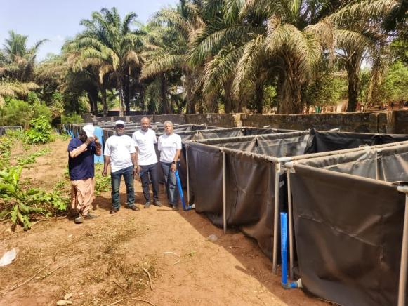
20 Installed tarpaulin fish ponds stocked with 10,000 catfish juveniles

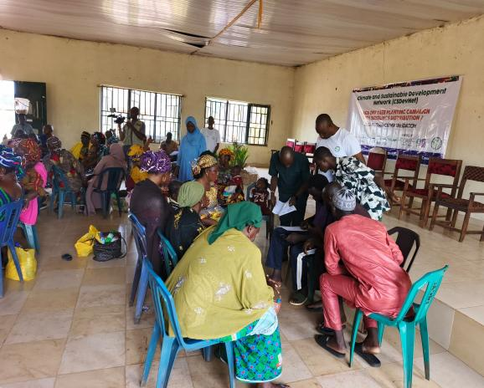
Participants at the CoGAP Validation meeting



CoGAP consultation and advocacy visit to Onu Ankpa & Ankpa LGA

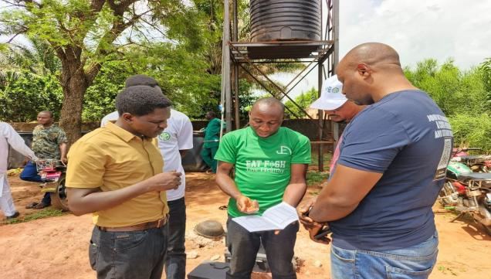
Project Team and GEF-SGP representatives during project site visitation
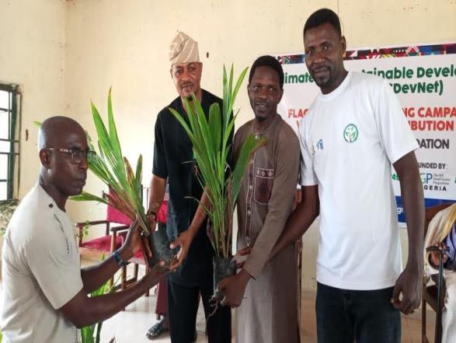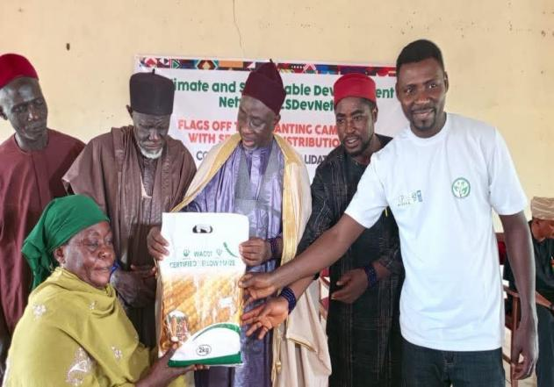
Distribution of Tree Seedlings and Improved maize seeds to cooperatives

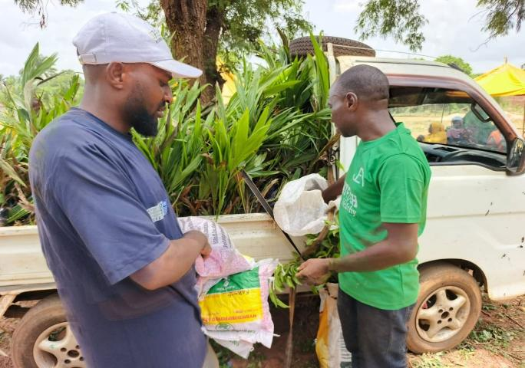
Arrival of Tenera tree seedlings at project site

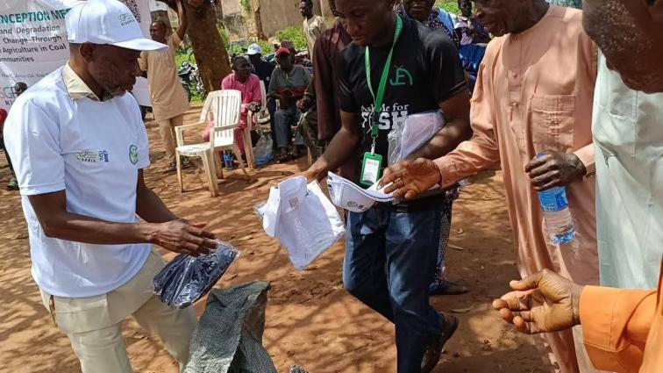

Distribution of IEC Materials

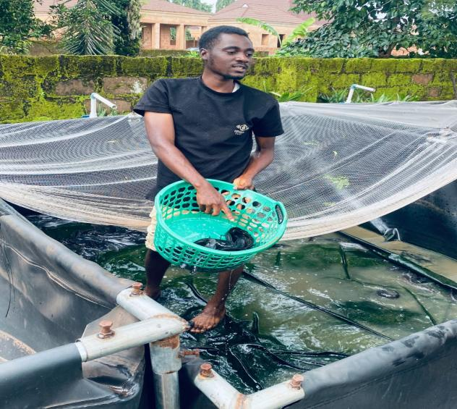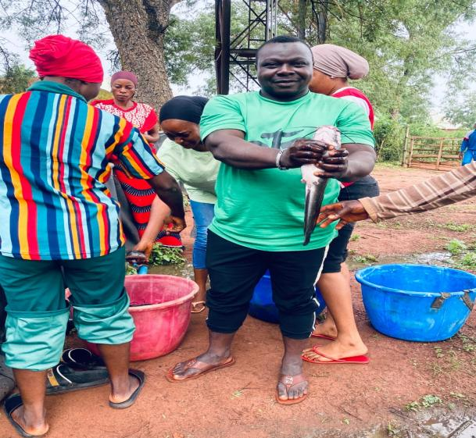

Aquaculture VSLA Group Harvesting

A FOUNDATION FOR THE FUTURE
The Enjema Climate-Smart Agriculture Project began as a response to the growing environmental and socio-economic challenges confronting a coal mining community. Land degradation, declining agricultural productivity, limited livelihood opportunities, and increasing climate variability threatened both the environment and the well-being of local households. What started as a community-based intervention has evolved into a broader model for integrated rural development, demonstrating that environmental restoration and economic prosperity can be achieved together.
Over the course of implementation, the project moved beyond delivering infrastructure and training to establishing systems that will continue to generate value long after project funding has ended. The installation of a solar-powered water system, establishment of an integrated demonstration farm, formation of Village Savings and Loan Associations, promotion of climate-smart agriculture and aquaculture, and development of the Community Green Action Plan have laid the foundations for sustained environmental stewardship and inclusive economic growth.
Equally important has been the strengthening of local institutions. Traditional leaders, community volunteers, women, youth, farmer groups, cooperatives, and local government have worked together to shape a shared vision for Enjema's future. Through this collaborative approach, environmental management has become a collective responsibility rather than the mandate of a single organisation or project.
The Community Green Action Plan represents the project's most enduring legacy. It provides a practical roadmap for restoring degraded landscapes, strengthening climate resilience, promoting sustainable livelihoods, and improving environmental governance over the coming years. As implementation continues, the CoGAP offers a platform for attracting new partnerships, mobilising climate finance, and integrating community priorities into local government planning.
The lessons from Enjema extend beyond a single community. They demonstrate that locally led solutions, supported by strong partnerships and informed by evidence, can address complex environmental challenges while creating lasting social and economic benefits. The approaches tested through this project provide a practical model that can be adapted and replicated across Ankpa Local Government Area, Kogi State, and other communities facing similar environmental pressures.
The journey does not end with the close of this project. It marks the beginning of a long-term commitment to protecting natural resources, strengthening community resilience, and creating sustainable opportunities for future generations. The foundations have been established. The responsibility for building upon them now rests with all partners committed to ensuring that Enjema continues to thrive as a resilient, productive, and environmentally sustainable community.

Final Reflection
"The true success of this project will not be measured by the activities completed, but by the lasting institutions it has strengthened, the landscapes it has helped restore, and the opportunities it has created for future generations. Enjema now stands not only as a beneficiary of development, but as a model of community-led climate resilience and sustainable transformation.

BACK COVER
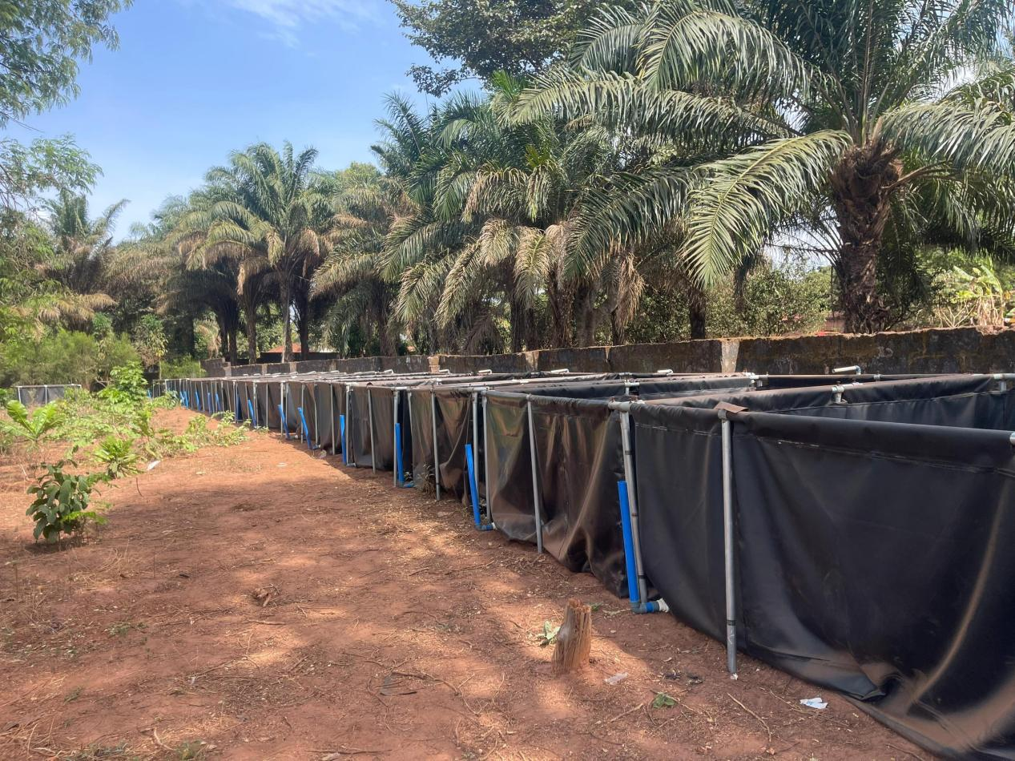
The Enjema experience demonstrates that environmental restoration is most effective when communities lead, institutions collaborate, and sustainable livelihoods are placed at the centre of development. The lessons from this project provide a practical model for strengthening resilience in mining-affected communities across Nigeria and beyond.

