**COMMUNIQUE ISSUED AT THE END OF THE STAKEHOLDERS’ DIALOGUE TO COMMEMORATE THE 2021 INTERNATIONAL WOMEN’S DAY, ORGANIZED BY CLIMATE AND SUSTAINABLE DEVELOPMETN NETWORK OF NIGERIA (CSDEVNET) IN COLLABORATION WITH GENDER AND ENVIRONMENTAL RISK REDUCTION INITIATIVE (GERI) WITH FUNDING FROM THE PAN-AFRICAN CLIMATE JUSTICE ALLIANCE (PACJA), ON THURSDAY, MARCH 18, 2021, AT BENUE CENTER FOR ENTERPRISE DEVELOPMENT & INNOVATION (BENCEDI) AUDITORIUM, MAKURDI, BENUE STATE.**

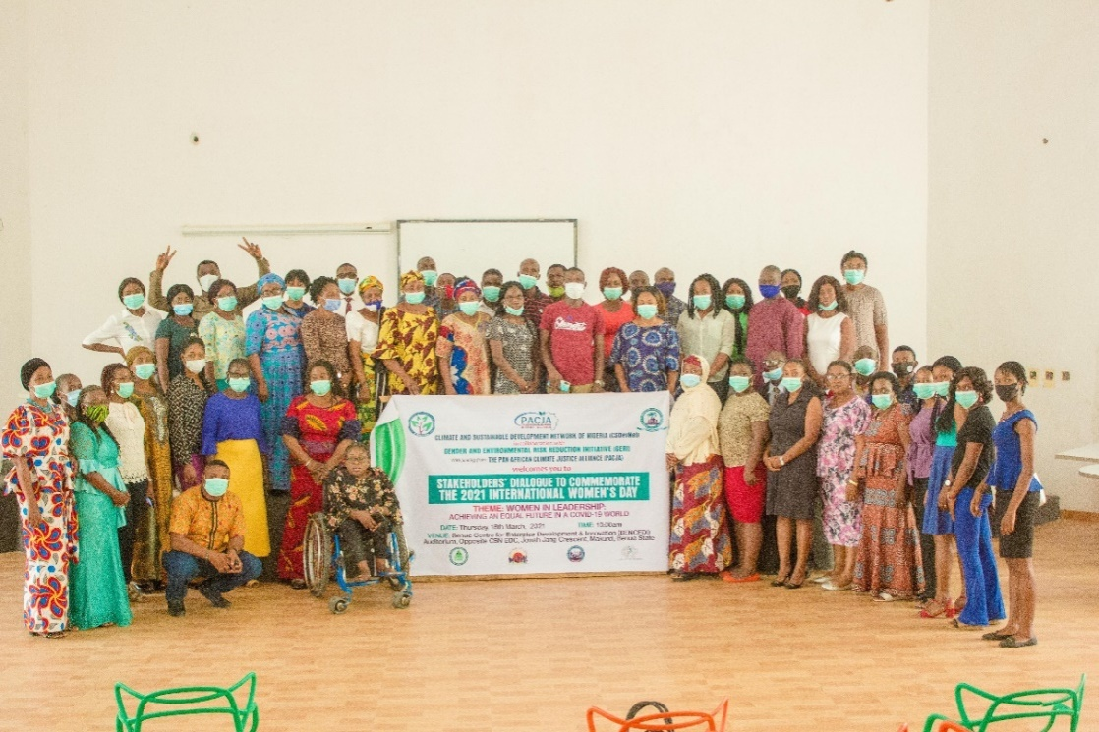

*Group picture of participants at the Stakeholders Dialogue.* ***Photo Credit: GERI***

**Makurdi, 18 March 2021:** Climate and Sustainable Development Network of Nigeria (CSDevNet) in collaboration with Gender and Environmental Risk Reduction Initiative (GERI) with funding from the Pan-African Climate Justice Alliance (PACJA), organized a stakeholders’ dialogue in commemoration of the 2021 International Women’s Day on Thursday, 18 March 2021. The event’s theme was this year’s theme for the International Women’s Day, “Women in Leadership: Achieving an equal future in a COVID-19 world”.

The event which took place at the Benue Centre for Enterprise Development & Innovation (BENCEDI) Auditorium in Makurdi, the Benue State capital, had in attendance key stakeholders from the civil society, media, health, students from tertiary institutions, and representatives of ministries, departments, and agencies of the Benue State Government.

In her opening remarks, the Executive Director, Gender and Environmental Risk Reduction Initiative (GERI), Ms. Elizabeth Jeiyol, spoke on behalf of the organizers, Climate and Sustainable Development Network of Nigeria (CSDevNet) and GERI, as well as the Pan-African Climate Justice Alliance (PACJA) who funded the event. Ms. Jeiyol welcomed guests and participants to the event and gave a broad explication of the purpose of the International Women’s Day and the stakeholders’ dialogue. She called on women to always support women and reiterated the need for collective action, involving men, to choose to challenge and call out gender bias and inequality for a more equal, more inclusive and more sustainable future.

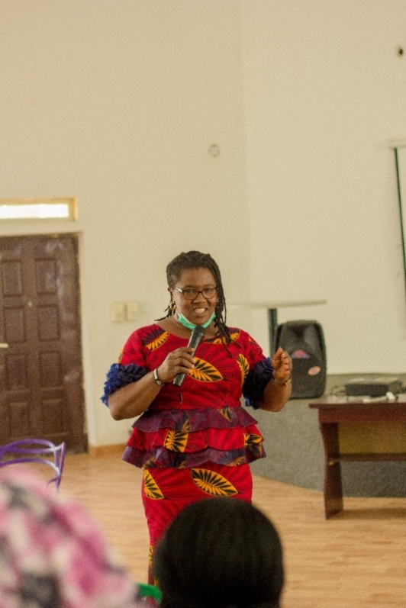

*Executive Director, GERI, Ms. Elizabeth Jeiyol, giving her welcome remarks.****Photo Credit: GERI***

The Benue State Commissioner for Water Resources and Environment, Engr. DondoAhire, who was represented by the Permanent Secretary of the ministry, lauded the organizers for conducting the stakeholders’ dialogue and stated the women are the key pillars to the growth of nations and should be celebrated and involved in decision-making processes. Also speaking, the Commissioner for Women Affairs and Social Development, Mrs. Tabitha Igirgi, who was represented by Mrs. Annas Anzan, appreciated the organizers for recognizing the need to celebrate women and the men for being present to collectively dialogue on ways to advocate for equality in the society.

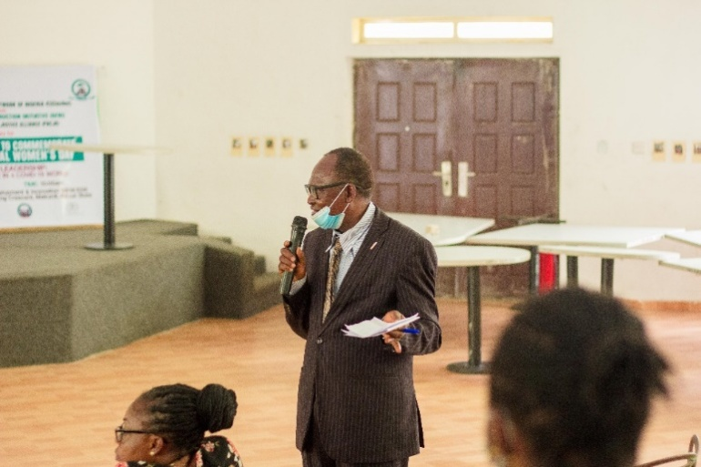

*Permanent Secretary, Ministry of Water Resources, Mr. Wilfred Ogili, giving a goodwill message on behalf of the Ministry.****Photo Credit: GERI***

In the first presentation, Mrs. Beatrice Shomkegh, a development expert, gave a talk on inspiring woman for leadership emphasizing the need to address the glaring issues bordering on social norms, stereotypes and socioeconomic structures that are still hindering the attainment of women in leadership position, especially in our socio-political context. The talk addressed questions around notions that exacerbate bias against women and the need for the inclusion of women and girls in post-COVID-19 recovery processes.

Mr. Tine Agernor, the Programme Manager, Eunice Spring of Life Foundation (ESLF) spoke on “the role of men in facilitating the inclusion of women in leadership and decision making” – addressing key issues around patriarchy, religion, culture, common humanity, positive masculinity, harmful gender norms, and breaking the culture of silence, which are key determinants exacerbating or de-escalating bias in the society. Mr. Tine Agernor, called on every participant to start applying certain principles of equality at their own spaces and advised them against, “allowing genitals to determine equality in the society” as women are more than capable in doing the things human beings are socialized into believing they are gendered.

Highlight of the event was experience sharing by stakeholders and participants. During this session, a woman who was a former contestant for the Ado Constituency of the Benue House of Assembly took participants through her journey through the muddy waters of politics when contested for the state legislative seat. She narrated how even her spouse was against her ambition and other women as well, who instead of supporting her, were against her – and she stated that the attitude of women not supporting women is one of the key loopholes that the society leverages on to deny women of their rights. Mrs. Hannah Ikyernum, the 1st Vice Chairperson (North-Central) of the Women’s Wing of Christian Association of Nigeria (WOWICAN) also narrated how her spouse inspired her to become what she is today, and called on the men present to learn from her husband exemplary character to mold her into the woman she has become. Several participants shared experiences on the challenges of inequality and how they have continued to scale through these challenges.